Task No & Title: Unit 1 | Unit Descriptor This unit defines the competency required to operate a personal computer, including starting the PC, logging in, using and understanding desktop icons and their links to underlying programs, navigating a directory structure, saving work, printing, system checks and closing down the PC. This unit is a prerequisite to starting the course and should be completed as soon as possible.
Title: | 01_02 Computer Hardware Quiz
Suitable for Classes: | Certificate II in Information Technology
Area: | Technology & Enterprise
Teacher: | Mr Peter Faulks
Timeline | 1 Lesson  1
Date Due: | Today 1 hour credit
Task Brief: | Identify parts quiz

Files Required

Items highlighted in yellow are tasks for you to complete
Items in Blue are help tips

Unit | Number | Title | Type | Hours
01 | ICAU1128B | Operate personal computer | Pre | 20
02 | BSBCMN106A | Follow workplace safety procedures | Core | 10
03 | ICAD2012B | Design organisational documents using computing packages | Core | 40
04 | CAU2005B | Operate computer hardware | Core | 20
05 | ICAU2006B | Operate computing packages | Core | 60
06 | ICAU2013A | Integrate Commercial computing packages | Core | 25
07 | ICAU2231B | Use computer operating system | Core | 20
08 | ICAW2001B | Work effectively in an IT environment | Core | 25
09 | ICAW2002B | Communicate in the workplace | Elective | 20
10 | ICAS2014B | Connect Hardware Peripherals | Elective | 25
11 | ICAU2007B | Maintenance of equipment and consumables | Elective | 15
12 | ICPMM263B | Access and use the internet | Elective | 20
13 | ICAW2011B | Work individually or as a team member | Elective | 20
14 | ICPMM321B | Capture a digital image | Elective | 30
 |  |  | TOTAL

Operate a Personal Computer
Cert II in Information Technology- Hardware Peripherals

ANSWER SHEET

01_02 Computer Hardware Quiz

The Four Basic Functions of a Computer
1. Input -- Input devices enable us to get information into a computer. Some
examples include (name at least 2)
Answer keyboard, mouse, microphone, scanner, or digital camera.
2. Storage -- There are two types of storage: temporary and long-term. RAM, what does RAM stand For?
Answer :random access memory,
RAM is temporary, meaning it stores information as you use it, but it is being constantly erased and rewritten as you open and close files.

Long-term storage holds information for as long as you want it.
List at least 2 storage devices
Answer : Hard drives, portable hard drives, floppy drives, flash drives, CD’s, and DVD’s are long term storage devices.
3. Processor -- A microprocessor controls the computers’ functions. It can be as small as a dime or larger such as 1-2" , but contains millions of transistors that perform millions of instructions per second. The microprocessor performs these instructions using a three-step process: F , D & E what do theses leters stand for?

Answer F = Fetch, D = decode and E - execute.
4. Output -- Information that has been processed is communicated back to the user in the form of words, sounds or pictures, and sometimes output is just written back to a storage devicebut often it is delivered through
output devices name at least 2 output devoces

Answer printers, speakers, monitors or other output devices.

Task Computer Basics Quiz
Q1. Draw the main parts of a computer and various hardware components
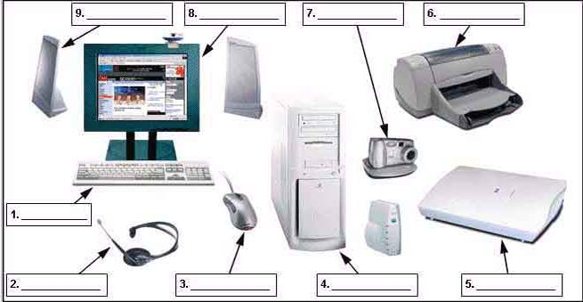

Label these computer parts
1 Keyboard
2 Headset (Microphone)
3 Mouse
4 CPU or Processing Unit or Case
5 Scanner
6 Ink Jet Printer
7 Camera (Digital)
8 Monitor
9 Stereo Speakers
10 Modem Router

Q2. List the main types of computers
Answer:
Windows, Macintosh, Linux

Q3. List and describe each function of a computer
Answer: The following are its functions:-
1.Program execution
2.I/O management
3.CPU scheduling
4.Error detection
5.Accounting
6.Protection and security
The Operating system provides and environment in which the user can interact with the computer hardware. it provides the user with an interface where the user can execute his programs.
It is a control program and plays an important role as a resource selector which means if a program needs any input /output devices then the operating system provides the means to do it.
or
An operating system (OS) is software, consisting of programs and data, that runs on computers and manages computer hardware resources and provides common services for efficient execution of various application software.

Q4. List and describe some storage devices and their basic categories
Answer: DVD, CD Rom, Hard Drive, ,
Hard drives, up to several terrabyte
Portable hard drives USB or Firewire Drive,
Floppy drives, Floppy Disk, 1.4Mb
Zip Disk 250Mb
Flash drives USB Drive, 64mb to several gigabyte
CD’s, 1.4 gb
DVD’s 4.2gb

Q5. How do you access system information from the Start Menu?
Start – Programs – Accessories – System Tools – System Information

Q6. What is a Jump Drive?
Portable drive that plugs into a USB port that files can be easily saved into

Q7. How do you add shortcut icons to the desktop?
In Windows Explorer or My Computer find the program icon you want to add in the Program Files directory and drag it into the Desktop Folder

Q8. How do you add programs into the start menu?
In Windows Explorer or My Computer find the program icon you want to add in the Program Files directory and drag it into the Start Menu folder

Q9. How do you find out the size of a folder – how many megabytes it contains?
Right mouse click on the folder - properties

Q10. How do you rename a file or folder?
Right mouse click - rename

Q11. If you delete a file how can you restore it?
Recycle Bin - Restore

Q12. How do you adjust the date and time on the desktop?
Right mouse click on the time – adjust date/time

Q13. What are 3 different ways you can access a file or folder?
Windows Explorer, My Computer, Any Software Program (eg:MS Word)

Q14. In Windows Explorer what are 3 ways to select multiple files?
Hold down the shift key, hold down the control key, click with the left mouse button and select the area
Q15. How do you add photos and slide shows to your desktop or screensaver?
Control Panel – Appearance – Change Desktop – Desktop - Browse
Q16. How do you change the way the files are displayed in the open dialogue box?
Click on the views icon
Q17. How do you check on the progress of a print job?
Start menu - Printers
Q18. How do you change the default printer?
Start menu – Printers – Right Mouse Click – Set as default printer

Q19. Name most the parts of the desktop in the picture below and the function of each.
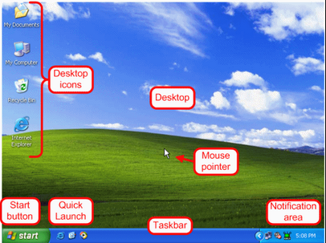

The Desktop

The center and right empty area you look at is actually the desktop. Whenever you are asked to use the desktop, the request refers to that whole area.

Taskbar
In the bottom section of the screen, there is (or there may be) a long object. It is called the Taskbar:

On the left side of the taskbar, there is an object labeled Start

Start
or . The appearance of this object depends on the type of Windows you are using but it plays the same role.
On the right side of Start, there is a wide area that is empty when the computer starts. This is actually referred to as the taskbar. As you keep using the computer, this area would be filled with some objects. In some versions (Windows 95, 98, Windows Server 2003), the color of the taskbar may be gray (or Silver). In some other versions (Windows Millennium), the taskbar may be yellowish. In Windows XP, it may be blue.

Desktop items

Short cut to applications

Start Button: Access to operating system and system tools

Notification Area : On the far right side of the taskbar is a section called the tray area. One of the things that this area displays is the current time (as set on your computer). Actions to be undertaken and information on time, hard drives etc

Mouse: Pointing Device movement and selection.

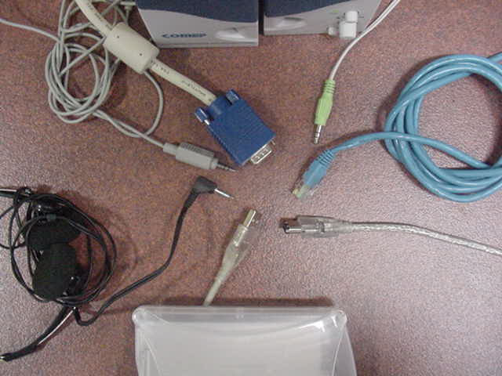
Draw arrows to identify each cable note there may be more than listed
Headphone Mini 3.5 USB Video Ethernet (network) Firewire Mini Speaker
Answer: (at least two sentences)

Manuals are A user guide or user's guide, to how to use software or hardware.

It is a technical communication most commonly associated with electronic goods, computer hardware and software. Most user ... The language used is matched to the intended audience, with jargon kept to a minimum or explained thoroughly. ….
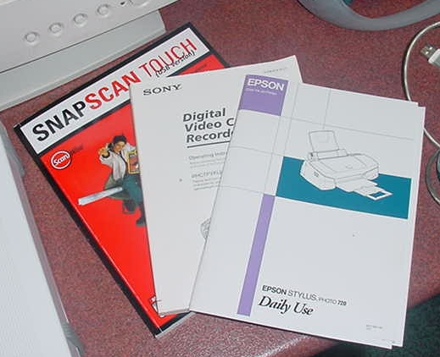

Draw arrows from labeled text boxes to each hardware component

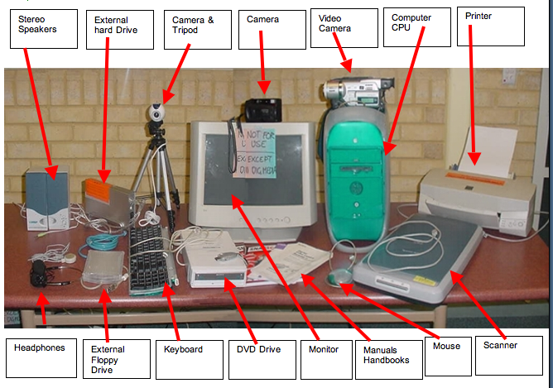

Label the common hardware used in the workplace.

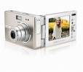 | 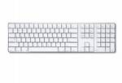 | 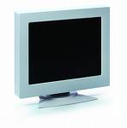 | 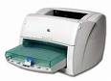
Digital Camera | Keyboard | Monitor | Ink Jet Printer
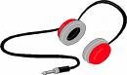 | 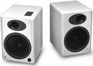 | 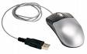 | 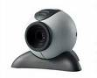
Stereo Headphones | Stereo Speakers | USB Mouse | Camera
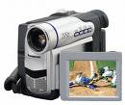 | 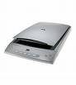 | 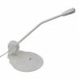 | 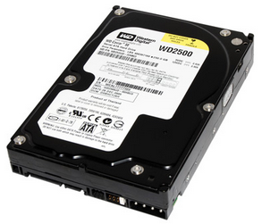
Vidoe Recorder | Scanner | Microphone | Hard Drive
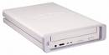 | 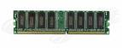 | 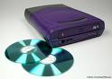 | 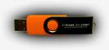
CD Burner | Ram Chip (Memory) | DVD Burner | USB Drive

Create your own marks

